Dewatering Screens

Over 30 years ago, McLanahan Corporation was the first to introduce Dewatering Screens to the mining industry, where the screens quickly became the standard. Dewatering screens offer multiple advantages for construction and specialty aggregate producers, including a dry “drip-free” product that other types of equipment cannot provide. With hundreds of units in service, the Dewatering Screen exemplifies the unbeatable toughness you expect from McLanahan Corporation. Contact Gulf Atlantic for information on how a McLanahan Dewatering Screen can benefit your operation.

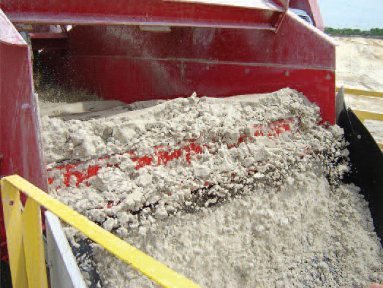  Click Photo to Watch the Video!  Click Here For Brochure!   How Does A Dewatering Screen Work?  Click Here To Find Out! | DEWATERING SCREEN USES:  - Dewatering  - Desliming  - Degritting  - Rinsing  - Scrubbing  - Washing  Available Sizes:  - 3' x 8'  - 4' x 10'  - 5' x 12'  - 6' x 12'  - 7' x 12'  - 7' x 16' | APPLICATIONS:  Aggregates & Industrial Minerals  • Cyclone / Separator Underflow  • Hydrosizer Underflow  • Feed To VSI, Dryers Or Other Moisture Sensitive  Operations  • Fines Recovery  • Aglime  • Screw Discharge  Coal  • Coal Spiral Products  • Shaking Table Products  • Heavy Media Feed Preparation  • Underground Mine Clean-up  Hard Rock Mining  • CIP / CIL Circuits  – Trash  – Loaded Carbon  – Safety Screens  – Carbon Quench  • Flotation Tailings

NOTE TO CARL: Video for above photo: http://www.youtube.com/watch?feature=player_embedded&v=bixsVTOjsrw
Website Location: http://www.mclanahan.com/index.php?page=aggregate-dewatering-screens
McLanahan Dewatering Screen Design Features  - High capacity  - Dewater finer products  - Multiple products on one machine  - Consistent drip-free discharge  - Upward inclination helps handle surges  - Better stockpile management and better housekeeping  - Shorter inventory cycle  - Control of gradation  - Low noise, low energy using vibratory motors  - Low maintenance | 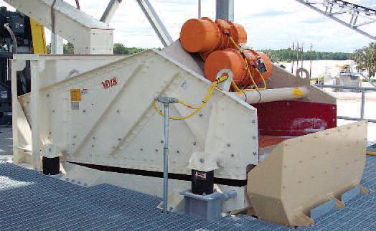

GET THE MCLANAHAN DEWATERING SCREEN ADVANTAGE  BENEFITS  - High Capacities Per Foot Width  - Consistent, Drip Free Product  - High G Force  - Upward Inclination Of Deck Helps To Handle  - Fluctuations In Feed Solids  - Reduces Water Losses To Product  - Better Stockpile Management  - Quiet & Low Power Consumption  - Driven By Vibratory Motors  - Low Maintenance  FEATURES  - High Quality Wear Liners  - Optional Deck Dividers  - Huck Bolt Construction  - Heavy Duty Urethane Screen Media | 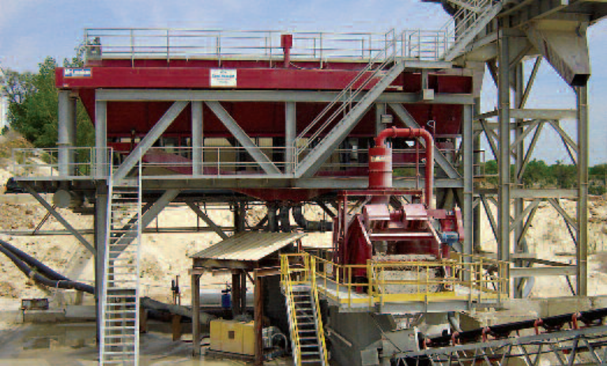  Silica sand processed through McLanahan’s Sand Manager ®  Classifying Tank is dewatered by a 7' x 16' dewatering screen.

IMPROVE YOUR BOTTOM LINE AND YOUR OPERATIONAL EFFICIENCY

McLanahan’s worldwide industry experience and just the right combination of frequency and amplitude means McLanahan Dewatering Screens provide drip-free discharge for applications that range from primary sand products to ultra fines recovery. The resulting improvements in housekeeping and immediate availability of products mean bottom line benefits!

McLanahan Dewatering Screens feature custom engineered, heavy duty screen media for the high capacity applications encountered in today’s production conscious market. Side frames and beams are Huck bolted together, not welded, so individual components can be replaced. They also have a combination of standard, high quality wear resistant side wear linings, optional deck dividers, and dams. Performance flexibility is enhanced by variations in screen media and the use of deck dividers. McLanahan Dewatering Screens have the highest capacities available in the industry and can process up to 400 tph of coarse sand on a single machine.

For more information or to receive a quotation on McLanahan Dewatering Screens, click here

Or Call Us at (800) 792-7427 or (352) 628-6674


